Stewardship and a Four-Legged Stool
Stewardship. We usually think of money, time, and talents. Money matters because as former Presiding Bishop Katharine Jefferts Schori said, “Property [and staff] allows us to do mission and ministry.” We usually associate time and talents with church stuff: committee work, serving as lectors or Eucharistic ministers, running the kitchen, changing lightbulbs. These all matter, but I would like to extend time and talent to social justice, especially in this fraught time of threatened mass deportations.
What American could we look to more for social justice activism than Martin Luther King, Jr.? In his latest book, America’s Original Sin: Racism, White Privilege and the Bridge to a new America, which I highly recommend, Jim Wallis devotes several pages to King’s “A Letter from Birmingham Jail.” Wallis appropriately calls it “[o]ne of the most important letters in American history, and in the history of the church in America” (italics mine). Wallis indirectly reminds us, as does another book I’m reading, The Politics of Jesús, by Miguel de la Torre (which I also highly recommend), matters spiritual, theological, and religious are political.
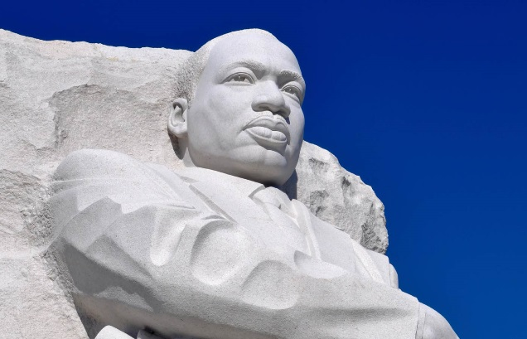
To Wallis’ assessment I would add King’s “I Have a Dream Speech”—and his radical at the time and now mostly forgotten sermon from 1967, “Why I Am Opposed to the War in Vietnam” (http://www.lib.berkeley.edu/MRC/pacificaviet/riversidetranscript.html). King, like a biblical prophet, or Jesus, declared that the war in Vietnam—like, we need to remember, our preemptive invasion of Iraq in 2003—was “unjust, evil, and futile.” But he also told a mostly-deaf public that “we spend $500,000 to kill each enemy soldier, while we spend only fifty-three dollars for each person classified as poor.” Has anything changed?
We in the Church are facing our biggest crisis since Vietnam. “Crisis” comes from the Greek word “to judge.” How will God judge what we do—or don’t do? In talking with the poor in our segregated ghettos, King came to a realization: “I could never again raise my voice against the violence of the oppressed in the ghettos without first having spoken clearly to the greatest purveyor of violence in the world today: my own government.”
Because of all this, King’s “Letter” may well be the most important scripture (yes) for us to read right now (https://www.theatlantic.com/politics/archive/2013/04/martin-luther-kings-letter-from-birmingham-jail/274668/). I plan to use it on Sundays during Lent. In his letter King is responding to tepid and timid white clergy, including Episcopalians, who called his social justice efforts “unwise and untimely.” Following Thomas Aquinas, King declared that “Any law that uplifts human personality is just. Any law that degrades human personality is unjust. All segregation statutes are unjust because segregation distorts the soul and damages the personality. It gives the segregator a false sense of superiority and the segregated a false sense of inferiority.”

“Segregation” still means racial segregation, but it now also characterizes laws against migrants, immigrants, the poor, the uneducated, and those who get government assistance with healthcare.

So where will we stand? Prayer is plenty, but prayer is not enough. As an Anglican, I would reconfigure our three-legged stool of scripture, tradition, and reason by adding a fourth leg: action. This fourth leg only makes the stool stronger.

Will we use action to stand with Brother Martin in opposing injustice and—more important—proposing God’s and Jesus’ justice?

