The Christ of War, the Christ of Peace
The Transfiguration
August 6, 2017

Exodus 34:29-35 Psalm 99 or 99:5-9
2 Peter 1:13-21 Luke 9:28-36

We celebrate today the Feast of the Transfiguration.

But this morning I’d like us to reflect on the nuclear holocausts of Hiroshima and Nagasaki.

I’d like us to reflect on the Christ of War and the Christ of Peace.

The holocausts in Japan in 1945 were modern humankind’s transfiguration, humanity’s transformation. You could even say that the horrors of World War II—the German death camps, the rape of Nanking, the fire bombings of Dresden and Tokyo, the holocausts of Hiroshima and Nagasaki— marked the criminalization of the human soul.

Today, 72 years ago, we dropped the atomic bomb on Hiroshima. Seventy percent of the city was destroyed. By year’s end, as many as 150,000 people had died.

This coming Wednesday 72 years ago, we dropped an atomic bomb on Nagasaki, killing 35,000 people.

When Jesus is transfigured, while he’s praying, the appearance of his face changes, and his clothes become dazzling white.

The first Christians told this sacred story because it represented for them God’s transfiguring love and presence in Jesus. They remembered God’s overwhelming presence in their lives, and now ours, with the symbolism of dazzling white clothing.

The dazzling white of modern humanity may well be the mushroom cloud.

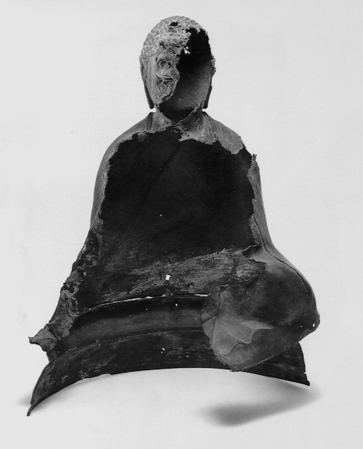
What would the Christ of Hiroshima and Nagasaki look like? A blackened, eviscerated, half-melted statue of Buddha?
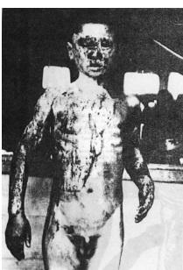
Or would he be a naked boy, maybe 12 years old, staring into the camera, his body seared and blackened like steak on the BBQ?

Like some of you, I am a child of the ‘60s. Which means I am a child of the War in Vietnam.

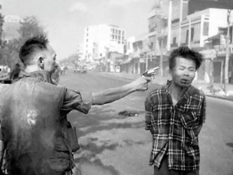
The Christ of Vietnam is the man being executed a few feet in front of a camera.
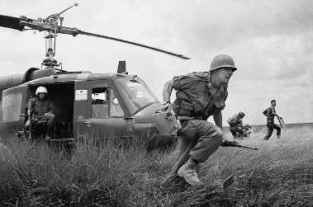
The Christ of Vietnam is the soldier being helicoptered into a rice paddy.
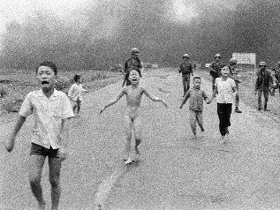

The Christ of Vietnam is the napalmed child running naked towards us.

The Christ of Vietnam is the Vietnam vet with PTSD that goes undiagnosed for 30 or 40 years.

The Christ of Vietnam is all the victims of war whom we would rather forget.

In his book Nothing Ever Dies, Viet Thanh Nguyen, a child of Vietnam, a refugee to this country, tells us what we don’t want to acknowledge: the Vietnam Veterans Memorial in Washington, D.C., memorializes more than 58,000 Americans. But the wall’s presence is also absence: it forgets, and allows us to forget, that two million civilians on both sides, over one million North Vietnamese and Viet Cong fighters, and perhaps 250,000 South Vietnamese soldiers died in the war.

All told, those numbers add up to 16 Hiroshimas and Nagasakis.
“The Washington, D.C., memorial to the American war dead is 150 yards in length; if a similar monument were built with the same density of names of the Vietnamese who died in [the war in Vietnam, the memorial] would be nine miles long.”

I was born in 1951, during the Korean war. Our country has been at war almost every year of my life. Unceasing war has seeped into our pores; it’s in the air we breathe; perhaps it’s even in the love we make.

Perhaps unceasing war has even transfigured our genetic makeup. This past May the Trump administration sought an increase to the military budget of about $53 billion, a 10% increase. Yet many in Congress said this increase was not enough.

These are the same members of Congress who want to slash Medicare and burn Medicaid.

Martin Luther King prophesied 50 years ago that war abroad dehumanizes not only the victims of those wars; it dehumanizes children of God who suffer here at home. In speaking about Lyndon Johnson’s “war on poverty” and support of civil rights, King offered this sorrowful lament:

A few years ago there was a shining moment in [the struggle for civil rights and justice]. It seemed as if there was a real promise of hope for the poor, both black and white, through the poverty program. . . . Then came the buildup in Vietnam, and I watched this program broken and eviscerated as if it were some idle political plaything of a society gone mad on war. And I knew that America would never invest the necessary funds or energies in rehabilitation of its poor so long as adventures like Vietnam continued to draw men [and women] and skills and money like some demonic, destructive suction tube. So I was increasingly compelled to see the war as an enemy of the poor and to attack it as such.

Half a century later, each and every word that King spoke is true. War in Vietnam, and now war in Iraq, Syria, and Afghanistan, is, King tells us, “the symptom of a far deeper malady within the American spirit.” As he concludes his address, he warns us:
We still have a choice today: nonviolent coexistence or violent coannihilation. We must move past indecision to action. We must find new ways to speak for peace . . . and justice throughout the developing world, a world that borders on our doors. If we do not act, we shall surely be dragged down the long, dark, and shameful corridors of time reserved for those who possess power without compassion, might without morality, and strength without sight.

Viet Thanh Nguyen points out the following painful truth: “Those who call themselves political,” he observes, “know that the most effective way to mobilize their adherents quickly is to terminate . . . empathy and compassion for others.”

Hillary Clinton confirmed this when she characterized Trump voters as “deplorables.”

Donald Trump confirms it on a daily basis.

And apparently about 40% of Americans don’t care.

In 1967 King commented on the “sad fact,” as he called it, of our desire for comfort, complacency, “morbid fear” of the other, and our “proneness to adjust to injustice.”

When we pre-emptively and immorally invaded Iraq in 2003, 77% of white evangelical Christians supported the war. At St. Paul’s we sang “Onward Christian Soldiers” and the rector supported the invasion from the pulpit.

Who would Jesus bomb?

In 2008, when the war in Iraq, now an occupation, had proven to be a disaster, evangelical leaders still supported U.S. military intervention.

As many as 200,000 civilians have died because of our invasion of Iraq.
When we invaded Iraq I told a clergy friend that Christians who supported the invasion were not Christians. He replied, “No, they’re bad Christians.”

So, what’s a good Christian supposed to do?

First, as our Jewish sisters and brothers remind us: Never forget.

Let us never forget that Jesus is a disciple of peace: “Blessed are the peacemakers, for they will be called children of God” (Matthew 5:9).

Let us never forget the victims of war, all victims, not just our own dead, wounded, and psychologically maimed.

Second, let us remember. Let us remember that each and every human being is a child of God, made in God’s image and likeness.

When we terminate our empathy and compassion for others, we in fact negate God. When we demonize others, or even demean them, we literally become atheists, those without God.

Finally, let us remember that we are children of incarnation. We are Spirit made flesh. Loved by God in heart, soul, mind, spirit, and body, we are called by God to use body, spirit, mind, soul, and heart to stand for peace and justice, to work for peace and justice.

In our liturgy today, St. Teresa of Ávila reminds us: “Christ has no body now on earth but yours; no hands but yours; no feet but yours. Yours are the eyes through which the compassion of Christ must look out on the world. Yours are the feet with which He is to go about doing good. Yours are the hands with which He is to bless His people.”

How will we bless others—and by doing so, bless ourselves?

By being peacemakers.

“When a particular war ends,” Viet Thanh Nguyen reminds us, “so may the antiwar movement opposed to it. Understanding that war is not a singular event but a perpetual one mobilizes a peace movement. This movement,” he continues, “looks beyond reacting to the war machine’s binary logic of us versus them, victim versus victimizer, good versus bad, and even winning versus losing.”

Blessed are the peacemakers for they shall be called children of God.

May the Christ of love, compassion, justice, and peace transform each and every one of us into Christ’s image and likeness.

Please take out the insert in your bulletin and pray responsively with me:

Prayers in Remembrance of Hiroshima
& Nagasaki

Blessed is our God, now and unto the ages of ages.

Blessed is our God, who grants us peace and is the source of all peace.
Blessed are the peacemakers for they shall be called children of God.

Loving God, you create and sustain all that is good and beautiful;
You give life to the earth.

You have called us to wholeness; to the fullness of life
But, as we gather here, we are conscious of our brokenness
Both as persons and as communities.

We have heard the cries for justice and peace
From all the corners of the earth.
We are moved by the tears, the pain, and the agonies of millions around the world.

We sense the dark clouds of war that creep over us;
We sit in the shadow of death.

Silence

Help us to fall on our knees and to cry for that vision of unity
Without which we would perish.

Teach us not to deal with others falsely,
Saying “peace, peace” when there is no peace.

Grant us grace that we may walk
In the paths of righteousness.

Bring us to yourself, that our hearts and minds
May discern the way of peace shown by your son.

For you alone have been our help in ages past,
And you are our shelter in the years ahead.

Amen.

https://en.wikipedia.org/wiki/Hiroshima#World_War_II_and_the_atomic_bombing_.281939.E2.80.931945.29.
https://en.wikipedia.org/wiki/Nagasaki#Atomic_bombing_of_Nagasaki_during_World_War_II.
Nothing Ever Dies: Vietnam and the Memory of War.
https://www.britannica.com/event/Vietnam-War.
Philip James Griffiths, cited in Nguyen, 66.
http://www.cnn.com/2017/05/23/politics/trump-defense-budget-increase/.
http://kingencyclopedia.stanford.edu/encyclopedia/documentsentry/doc_beyond_vietnam/.
See Benjamin Hedin, “Martin Luther King, Jr.,’s Searing Antiwar Speech, Fifty Years Later,” “http://www.newyorker.com/culture/culture-desk/martin-luther-king-jr-s-searing-antiwar-speech-fifty-years-later.
Nguyen, 267.
http://www.religionnewsblog.com/14002/why-evangelical-christians-march-on-the-iraq-warpath.
http://www.christianpost.com/news/most-evangelical-leaders-still-support-iraq-war-31154/.
Nguyen, 265.

